|  |
| --- |
| STV Incorporated |
| AutoCAD 2013 |
| TUTORIAL |
|  |
| **Ana C. Gouveia** |
| **3/25/2016** |

|  |
| --- |
|  |

Table of Contents

AUTOCAD SET UP 4

1. InTRODUCTION & General Set Up 4

1.1 How to change the color of your cursor and other general configurations. 5

1.2 Install or Re-Install STV Tool Palette Groups 5

1.3 Recommended Screen Setup 5

1.4 Model Space Setup 6

1.5 Paper Space (Layout) Setup 6

1.5.1 Layouts have specific configurations set up: 6

1.5.2 Layouts can have specific project templates: 8

1.5.3 How to create/edit viewports 9

1.6 Installing AutoCAD apps 11

1.6.1 Loading SteelPLUS 11

1.7 Important Standards 12

HOW TO 13

2. Getting a Drawing Started: 13

2.1 Start a New Drawing 13

2.2 How to use Tool Palettes: 13

2.2.1 Using Layers 14

2.2.2 How to Import Layers and Dimension Styles (dim style) 14

2.3 Drawing in Multi-Grids 17

3. DRAWING / Formatting: 17

3.2 Geometric Shapes Available 17

3.3 Modifying Functions 17

3.4 Annotation 18

3.4.1 Stacked Fractions 18

3.4.2 How To Place Leaders 18

3.4.3 Superscripts & Subscripts 19

4. further processing: 19

4.1 How To Create A Sheet Set 19

4.2 Create And Edit Blocks 20

4.3 Calculate Mass & Area Properties 20

4.4 How To Plot Or Print: 23

4.4.1 Plotting from Sheet Sets 24

4.4.2 PDF Plotting 26

EXPORTING AUTOCAD DRAWINGS 28

5. Exporting Into Revit 28

6. Exporting Into Abaqus 28

CAD EXERCISE 29

1. Foundation Exercise 29

1.1 Objective 29

1.2 Procedure 29

1.3 Paper Space Set Up 29

1.4 Model Space Set Up 30

1.5 Drawing 30

1.6 Adding Dimensions 31

1.7 Creating Viewports 31

1.8 X-Reference Title Block 32

1.9 Align Details 32

1.10 Print Drawing 33

REFERENCES 34

# AUTOCAD SET UP

# InTRODUCTION & General Set Up

AutoCAD is a very useful application for drafting. It can be used on its own or associated to a variety of other applications for further purposes, for example a drawing can be exported to Abaqus for a stress analysis.

Certain set ups in AutoCAD will facilitate its general use and ensure that drafting can be executed in a timely manner. Figure 1 show a general screen set up. Main tools in AutoCAD are circled in red in the figure, and listed below.

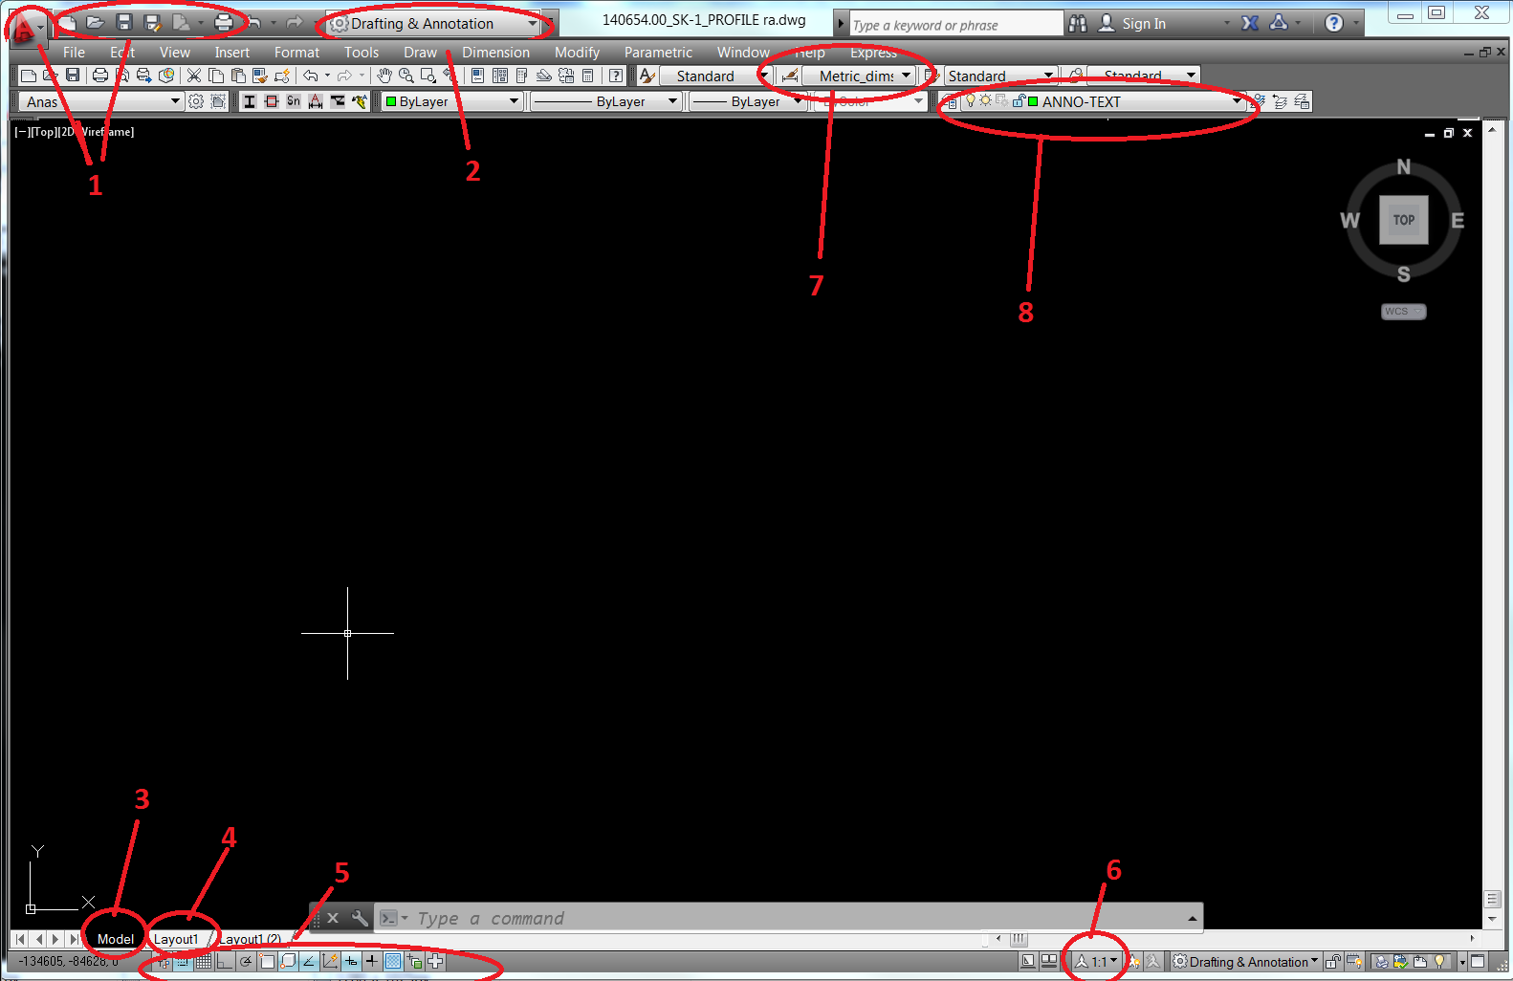

Figure – AutoCAD main/general screen.

Where:

1 – AutoCAD basic buttons (save/open/print)

2 – AutoCAD screen layout (generally set to AutoCAD classic)

3 – Model Space tab (it may sometimes be hidden)

4 – Paper Space (Layout) tab (it may sometimes be hidden)

5 – AutoCAD assistance tools (F3 – Snap ON/OFF; F8 – Ortho mode)

6 – Scale

7 – Dim styles (Text Styles)

8 – Layers

## How to change the color of your cursor and other general configurations.

If you are working on a drawing with a PDF background, it helps to change your cursor to a different color so that it doesn’t get lost in the drawing.

Steps:

1. Switch your workspace to AutoCAD Classic. This is done through the dropdown with the gear symbol in the top left corner of your window.
2. Go to the Tools dropdown and click on options.
3. Click on the ‘Drafting’ tab and hit the ‘Colors…’ button.
4. Under Interface element click on ‘Crosshairs’ and choose your preferred color.

## Install or Re-Install STV Tool Palette Groups

STV Tool Palettes provide a large number of commonly used items so that you do not need to draw them every time you use them, items available in the Tool Pallets range from breaklines to hatches to channel sections. Title blocks, dim styles and standard layers can also be found in the tool palette.

Steps:

1. Open AutoCAD 2013.
2. Select Tools > Options (or use the command ‘Options’).
3. In the Options window, select the right-most tab “Profiles”.
4. Click on “Import” and go to:

I:\BOS\Drafting Standards\_AutoCAD Shared\_Setup\ACAD2013-BOS Network

1. Select ACAD2013-BOS Network and click “Set Current”. Close the Options window.
2. You can now access the STV Tool Palettes from Tools > Palettes > Tool Palettes, or from the palette in itself.

## Recommended Screen Setup

There are several palettes that will be useful while drafting. STV recommends that the following tabs are open and set onto your secondary screen.

Steps:

1. While on AutoCAD 2013, click on the AutoCAD screen layout (Part 2 on Figure 1) and select AutoCAD classic.
2. Next, click on the Tools Tab (sixth from left to right at the top of the screen in an AutoCAD classic view), go to Palettes and select the following palettes: Tool Palettes; Properties, Sheet Set Manager. You’ll nee3d to click on them individually.
3. Next, to open the layer window type LA.
4. In the same fashion as part 2, type XR, to open the Reference Palette.
5. The last tab needed is the Design Center – which will hold all of STVs template setups.
6. After you have all tabs open, arrange them in your secondary screen, however you find convenient.
7. Next, go to Tools > Workspace > Save Current As…
8. A new dialog box will pop up, name and save the current space. This step will ensure that every time you access AutoCAD, the 2 screen set up you’ve just configured is saved and ready to be used.

## Model Space Setup

Generally, any work done in AutoCAD is done in the Model Space. Normally, it has a scale of 1ft, that is, if you draw a line with a dimension of 1, it will be 1 ft long. For a better understanding of scales please read **Error! Reference source not found.** in this manual.

## Paper Space (Layout) Setup

Once a drawing is done it can be opened in the paper space in order to be plot. Three main reasons why paper space is used for plotting: layouts have specific configurations setup; they can be set up as a standard for a project and be x-referenced into all project’s drawings; and they can show different drawings and scales.

### Layouts have specific configurations set up:

The paper space can be set to print exactly what you need. It can have different dimensions (Ex: Letter size 8.5x11 or D-sized paper 36x24), and different orientations (landscape or portrait). Further, a drawing (from model space) can have multiple layouts (multiple pages), with different configurations. It is STV’s standards to have one layout per drawing, however, for smaller drawings (11x17 or 8.5x11) multiple layouts (multi-tabs representing different paper spaces) for a drawing are allowed (Please check with your head Drafter).

#### How to setup paper space dimensions & orientation

To set up the paper space dimension follow the following steps.

Steps

1. **Right click** on the Layout tab on the bottom of the screen (Figure 2).
2. The “Page Setup Manager” dialog box will pop up (Figure 3). Click **Import.**
3. The “Select Page Setup From File” dialog box will pop up (Figure 4). **Locate** the location of AutoCAD templates on your computer. Currently, templates can be found at I:\BOS\Drafting Standards\_AutoCAD Shared\_Templates . Once the location cited above is found, the dialog box should look like the one in Figure 4. In this case, **click Boston Templates**, then, select a template, such as BT-E-Land-42x30_2006. Click **Open.**
4. The “Import Page Setups” dialog box will pop up (Figure 5a). Select the style you’d like to use and click **OK.**
5. The “Page Setup Manager” dialog box will show up again (Figure 5b). Select the layout chosen and click **Set Current**. The selected page setup details are displayed on the bottom of the dialog box as shown in Figure 5b. Click **Close.**

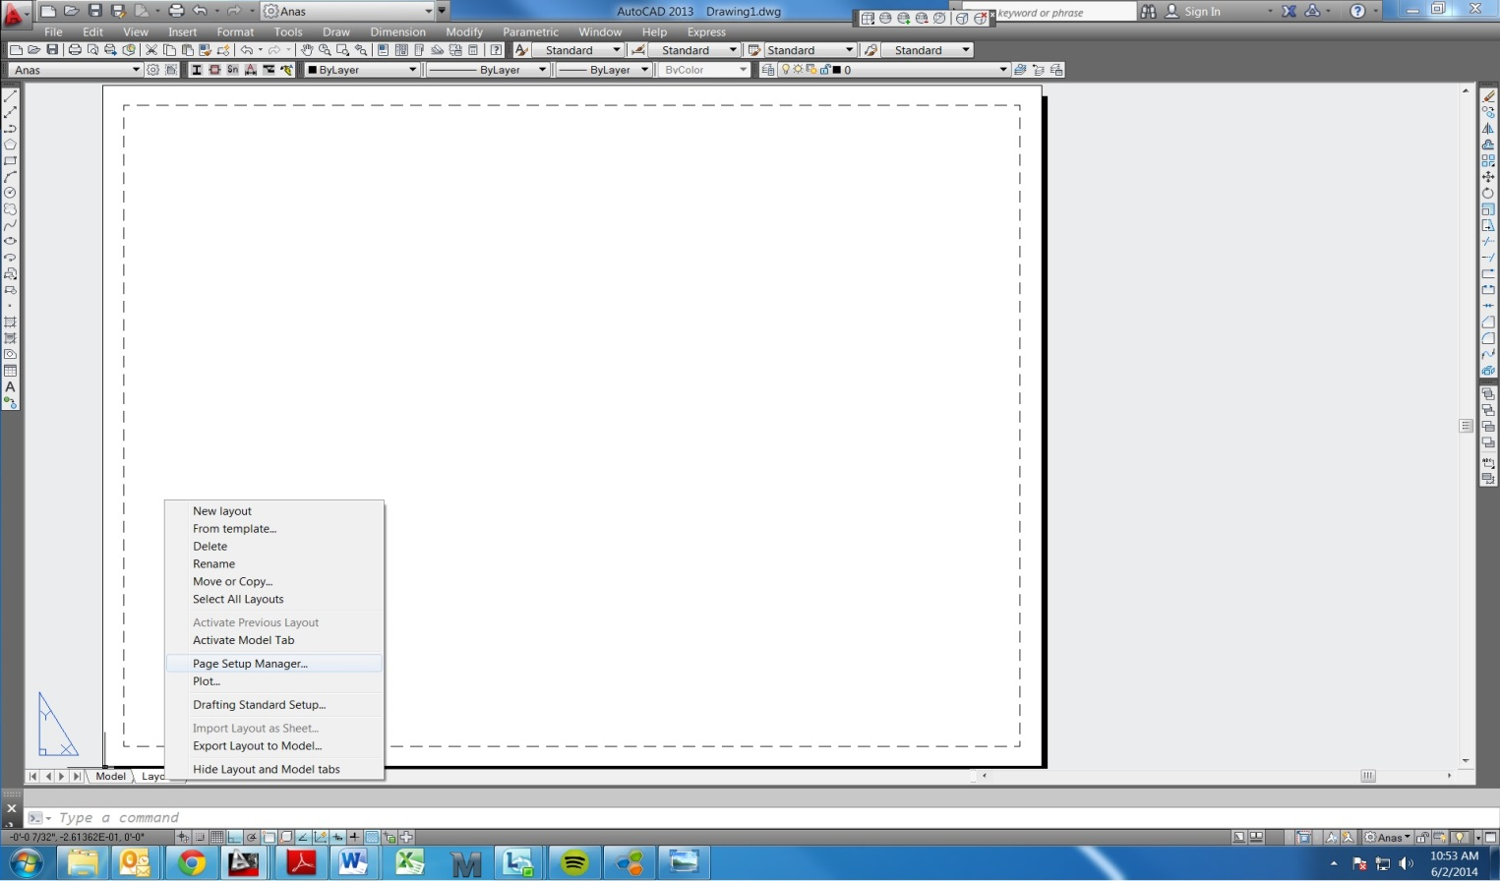

Figure – How to setup paper space dimensions & orientation

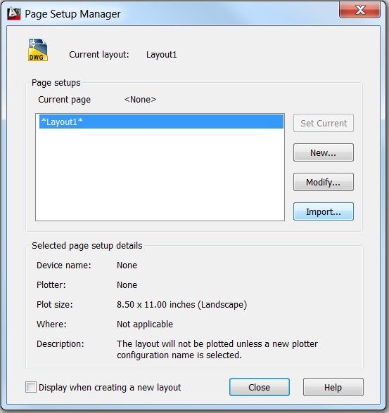

Figure – Page Set Up Manager

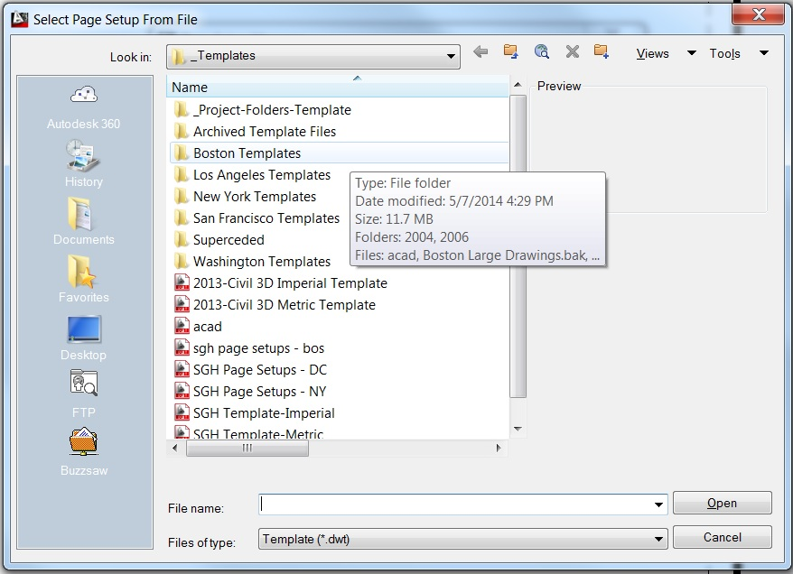

Figure – Select Page Set Up from File

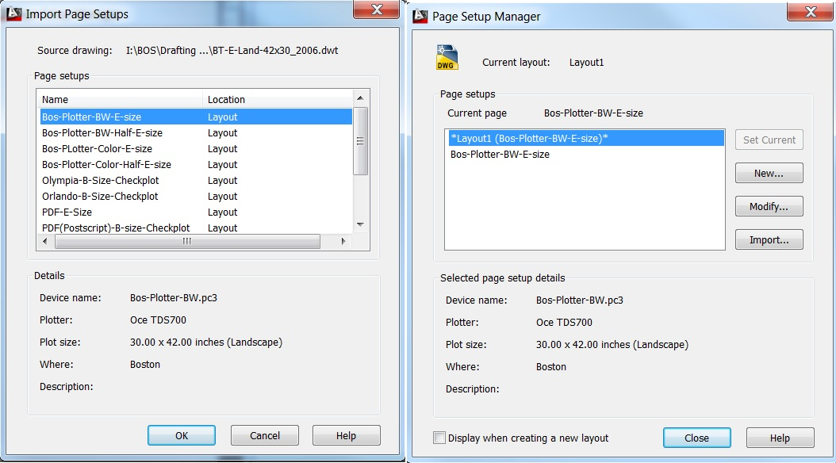

Figure a/b- Import Page Setups & Page Setup Manager

### Layouts can have specific project templates:

For larger projects (or projects with multiple drawings) it is common to create a drawing of a title block (or to use an existing drawing). Title blocks are basically the template for the page to be plot. The title block of a project is saved in the _support folder of a Project’s Drawing Working Set, and from there it can be used in multiple drawings of the project, by “x-refing” that support drawing into the project drawings layout page.

#### How to Create / Edit a Title Block / Template / Layout:

To create or edit a title block:

Steps:

1. Open the title block drawing in AutoCAD.

2. Do the necessary modifications in Model Space.

3. Save the drawing.

#### How to X-Reference a template:

To insert a title block onto a the paper space and use it as a project template you’ll need to “X-Ref” the title block drawing.

Steps:

1. Open the drawing you wish to insert the template
2. Go to paper space
3. Type XR or go to your XRef palette and insert drawing. (by right clicking in the XRef box or the Insert Button).
4. Select Relative Path whenever possible; and insert the drawing at 0,0.
5. The drawing should now be paste onto your paper space.
6. Observe that in some cases you’ll need to get the title block text from the tool palette or copy and paste for certain information that belong to the specific drawing you are working on.
7. Also note that, modifications on the sheet/template can be done by editing a title block (1.5.2.1)
8. Please note that layout/paper space tabs, can be copied and paste (thus making your job of creating many similar layouts faster).

### How to create/edit viewports

Paper Space can show multiple drawings with or without different scales. In order to bring drawings into paper space, viewports are created. A page can hold multiple viewports and each one of those can hold different configurations (for example each one of the viewports can have a different scale). There are two ways to have viewports inserted to your page: By creating them or by pasting a viewport title block from your palette.

#### To create a viewport on your page:

1. Go to View > Viewports > New Viewports

2. That should allow you to insert a viewport onto your paper space – similarly to drawing a rectangle.

3. You may repeat the process as many times as necessary;

4. Next you will need to set the picture inside the viewport to what’s drawn on your model space – Click inside the viewport, type z, then type e. Find the drawing you want to show on your plot. Now adjust the viewport to the appropriate (required) scale;

5. To set up the scale of a viewport – on the bottom right of your screen, you’ll find a button that says viewport scale (See Figure 5), click on it, and set it to your desired scale. Note that different scales may be created as necessary.

#### To insert a multi-viewport on your page:

Multi-Viewports are used with multi-grids. They basically hold multi-viewports that show the different scales being drawn on the multi-grids on model space. To insert one:

1. Go to Title Block Tool Palette > Multi viewport

2. Click on the viewport and insert at 0,0 on your paper space

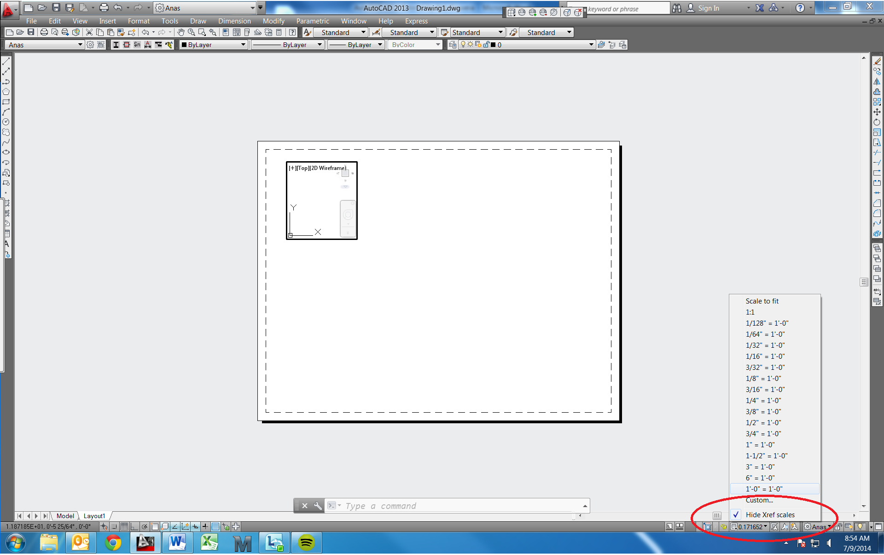

Figure 5 – Viewport Scales

#### How To Set Viewports To The Right Scale

When you create a viewport to display part or all of your drawing in model space you will need to scale it correctly (unless the drawing is intentionally drawn not-to-scale).

Steps

1. Double click in your viewport to activate modelspace in that view port.
2. Center the drawing on what you want to show and type ‘z’ and hit enter to zoom the drawing.
3. For the next step you need to know the scale factor for the drawing scale you wish to have (i.e. 12 for 1”=1’-0” scale, 16 for ¾”=1’-0”, etc.). The scale factor can be found by the following formula:

Given x/y = 1’-0”,

Scale factor = 12y / x

1. Type “1/##xp” and hit enter, where ## is replaced by your scale factor. If you have your page setup set correctly, your drawing in that viewport will now appear as the correct size when plotted.

## Installing AutoCAD apps

There are many AutoCAD application files that have been created to reduce the amount of time it takes to perform routine (and sometimes complicated) tasks. For example, there is no standard command in AutoCAD that can tell you the combined length of multiple objects. However there are many applications that have been written to perform just such a task. It is simply a matter of finding whatever application you need, whether internally, or on the internet.

Steps

1. The first task is to find a “.isp” file which is the application you will need to have on your computer. One way to find .isp files is simply to search for them on google by describing the task you wish to complete (such as “How to find the length of multiple lines in autocad”) or specifically you can look on Autodesk discussion groups (discussion.autodesk.com).
2. Several example files have been placed in the same folder as this manual. The file “length.isp” calculates the total length of many lines; “tparea.isp” calculates the total area of many objects; “hatchb.isp” draws the boundary of a borderless hatch.
3. Save the .isp file somewhere convenient for you to find, such your desktop or user space.
4. In AutoCAD type the command “appload”. A new window should appear.
5. Browse to the .isp you wish to add and select “Load” and close the window.
6. You should now be able to use the application by typing the command, which will be the same as the filename of that application.

### Loading SteelPLUS

Steel plus is a useful application which allows you to import steel shapes as pre-drawn blocks. You can choose the type of shape (w-beam, angle, channel, etc.) and the size that you want. There is also an option to see the member in plan, elevation, or section. This will save you a lot of time if you are working on drawings that contain steel members.

Steps

1. Switch your workspace to AutoCAD Classic. This is done through the dropdown with the gear symbol in the top left corner of your window.
2. Go to tools >> customize >> interface. A dialogue box named ‘Customize User Interface’ will appear.
3. Click on the folder symbol next to the ‘All Customization Files’ dropdown.
4. Go to:

I:\BOS\Drafting Standards\_AutoCAD Shared\_Utilities\stlplus-I\VR14

1. Click on the CUIX file named STL14WIN and hit open.
2. In the Customize User Interface box hit Apply and then OK.
3. A box should appear in your toolbar with steel shapes on it. If not, right click on an empty area of your tool box and highlight STLPLUS. Choose Steel PLUS VR14.

## Important Standards

1. Always work on drawings in the appropriate sub folder under the Working_Set directory. (i.e. _Elevations, _Sketches, etc.) In general, do not make copies of the drawings to work off of because you cannot control who makes alterations to the original in the meantime.
2. Avoid overriding dimensions to make them say what they ought to be. If the dimension is wrong, fix the drawing.
3. When drawing hatches, it usually beneficial later on in the project if you make the hatch associative to the borders of the area. This can be completed by checking off the “Associative” box under Options in the Hatch window. Now if you move the corner of the border (either by selecting a point on the polyline, or selecting two intersecting lines and move the corner) the hatch will expand or crop with it. Note: This does not apply to AutoCAD 2010 or later versions, where hatches are automatically associative.

# HOW TO

# Getting a Drawing Started:

## Start a New Drawing

When starting a new drawing, you should usually begin with one of the STV Templates because they will have all of the standard layers, page sizes, dimension styles, etc. that you may need for your drawing.

Steps:

1. Open a new file (File > New).
2. If the Templates directory is not open, it can be found under: I:\BOS\Drafting Standards\_AutoCAD Shared\_Templates\. You may be required to change the “file type” drop down menu to a drawing template file (.dwt). You should now see a list of templates.
3. You will probably want: “STV Template-Imperial”. Open the desired template.

## How to use Tool Palettes:

Tool Palettes are very helpful. Title Blocks, dimension styles (dim styles), and other drawing blocks can be brought from it onto your drawing – instead of having to be drawn every time. In Figure 2 you have an overview of how the Tool Palette should look like. In the tool palette dialog box, you’ll generally find the following commands:

*1 – Current Tool Palette*

By right clicking on the bottom left corner you should be able to choose which Tool Palette you’d like to work with. STV has three standard palettes that are added through the Installation explained above: SESM, BT and Title Blocks. In general the **SESM palette** should have STV layers, annotation blocks, dim styles and other objects. **The BT palette** should have items that are generally used by the division. **In the Title Blocks palette** you’ll find common used Title blocks (such as paper space layouts, grids and multi-grids).

*2 – STV layers*

*3 – Object Tabs* (Annotation objects, Civil, Connections and other items can be found on these)

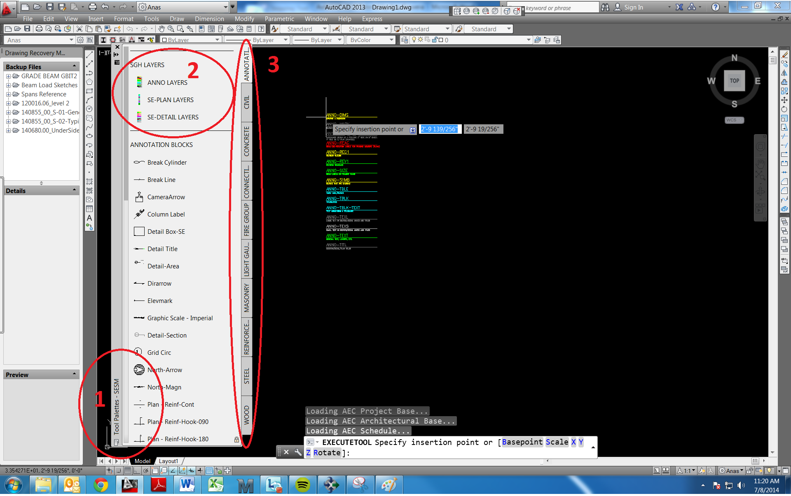

Figure 2 – Tool Palette Overview

### Using Layers

In general, drawings are made using different layers in order to differentiate the different materials & conditions that are being drawn. STV like other companies have standard layers for its different divisions (and its different uses). To import the layers:

Steps:

1. On the Tool Palette, right click on the bottom of your tool palette and select SESM.
2. Once on the SESM Tool Palette > On top of the palette click and place the STV layer needed on the model space. (See Figure 2)
3. The layers imported should now populate your layer properties manager box.

### How to Import Layers and Dimension Styles (dim style)

In general, once a drawing is started, it starts without dimension style and layers (Figure 3). To import layers and new dim style, simply click on the dim style or layer you are searching for on the Tool Palette and paste (by clicking it) it on your model space. Figure 2 shows a layer being paste onto model space.

Note that, in general, the model space will have a 1:1 scale. Drawings, however, have scales that are determined by the real dimensions of the object being drawn and page layout it is to be print.

By selecting the appropriate dim style, the annotations & objects in the drawing will be on the appropriate scale once they are plot. Note that, by selecting a dim style in the control box (The control box can be found in part 7 of Figure 1) anything imported onto CAD from the Tool Palette will then have the scale associated to that dim style previously selected. See below the steps on how to import a dim style.

Example:

You are going to produce a drawing in a ¼ in scale. In the Draft Sheet distributed by your head drafter you’ll find that a ¼ scale drawing requires a scale factor of 48. This basically means that in your model space (which stays at a 1:1 scale) you should bring a dim style 048.

Click on dim style 048 on the Tool Palette and place it on your model space.

You may need to use multiple dim styles, once certain dim styles are imported, the Dim Style Control box should look similar to Figure 4.

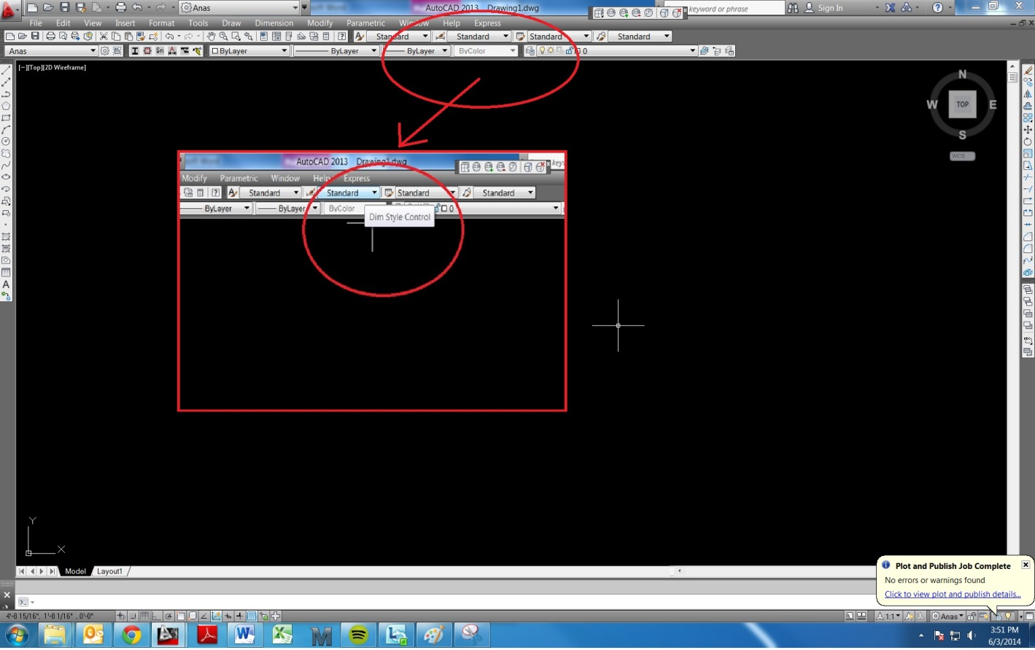

Figure 3 – Dim styles and configurations.

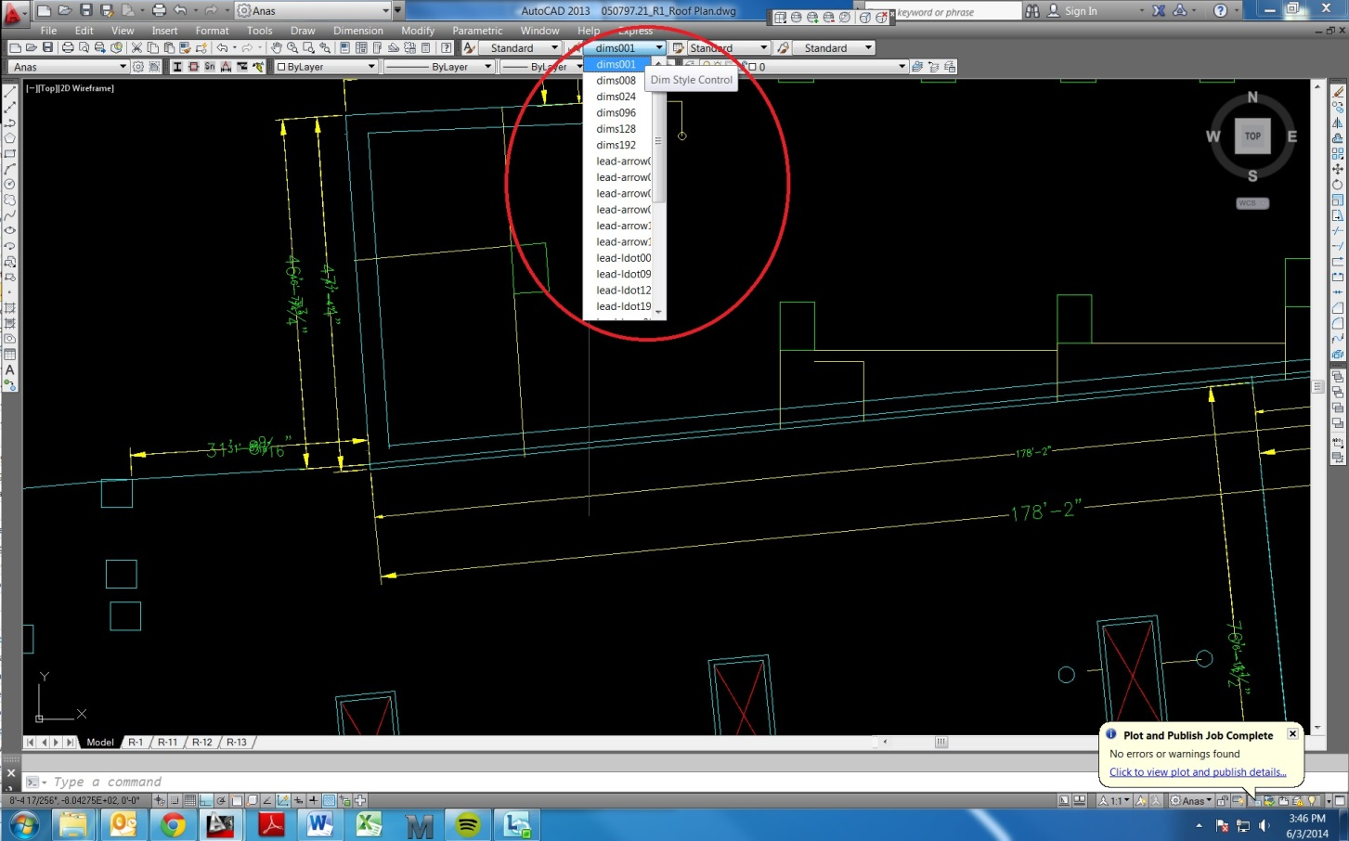

Figure 4 – Dim styles control box.

#### Add New Dimension Styles

Usually when adding leaders you can use one of the existing dimension styles (such as dims008, or lead-arrow016, etc.), however there are times when you may require a different style. For example consider if you wished to use a 1/16”=1’-0” scale which has a scale factor if 192:

Note: These steps assume you already have the standard STV dimension styles in that drawing. If you do not, see How to import standard dimension styles.

Steps:

1. Start the Dimension Styles Manager by clicking on:

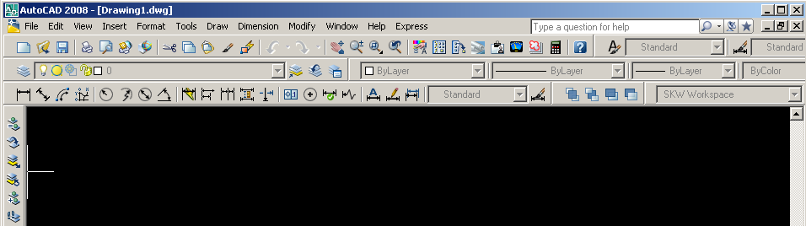

1. Click on ‘New…’
2. Change the ‘New Style Name:’ to “dims192” and change ‘Start With’ to any of the existing “dims###’. Click ‘Continue’.
3. Under the ‘Fit’ tab, set the ‘Use overall scale of:’ to 192. This will automatically correct the size all lines, arrows and symbols, and text.
4. Repeat this process for all the leader types you need to use (i.e. lead-arrow, lead-loop, etc.) but be sure to change the ‘Start With’ entry to one of the existing dimension styles that already has the correct end symbols (arrows, loops, etc.).
5. You can also modify other aspects other than the scale of the dimension styles using the Dimension Style Manager. However this is not generally recommended to ensure that the leaders and dimensions match STV’s AutoCAD standards.

#### How to import objects from the Tool Palette

See 1.2.2.1.

## Drawing in Multi-Grids

Certain drawings, typically Details have multiple objects drawn. These objects can also be drawn in different scales. To draw objects in different scales for one page layout, you must import the Multi-Grid from the tool palette. After clicking on the Multi-Grid block on the Tool Palette, bring your mouse to your model space. Next to the cursor it will ask for insertion point of your multi-grid. Type: 0 , 0 . (Zero – Comma – Zero) That will ensure the grid is inserted at the coordinates 0,0 of the model space.

Once in place, you will note multiple boxes. Each of these represent a scale in which drawings can be made. Technically, the drawing in model space will be a real representation of the object (1:1 scale), it is by inserting a multi-grid viewport onto your layout that you’ll obtain a view of all grids you have on your model space – associated to its appropriate scale.

To plot a multi-grid drawing, you will need to repeat the same procedure as for the multi-grid block, with the exception that instead of using a multi-grid block, you will select the multi-grid view port from your tool palette and past the block at 0,0 on your paper space. Note that, the viewports are separated by the sheet size you are plotting to.

# DRAWING / Formatting:

AutoCAD have many functions that will allow you to draw – and to draw fast.

## Geometric Shapes Available

In general drawings are made out of lines. However, keep in mind that you may use polylines, rectangles, circles and such.

## Modifying Functions

Basic keys to remember and use:

F3 – OBJECT SNAP : It snaps onto points on an object. You may select the types of points you wish to snap by change its configurations (Right click on the left bottom of the screen)

F8 – ORTHO: If ortho is ON you’ll make sure that whatever you are working will be on a straight line from the point where you start it – or orthogonal.

Typing functions:

These functions are generally typed – although they can be accessed from the Modify pull down menu. They are very useful in the process of drawing / editing a drawing.

CO – copy (copies an object)

O – offset (offsets by coping an object through a certain distance)

EX – extend your object (for instance a line) to a selected object (another line representing an edge)

TR – trims an object

MI – mirror your object relative to a selected point

ARRAY – makes an array

## Annotation

### Stacked Fractions

Unless otherwise specified, fractions should always be written as ½ rather than 1/2. There are at least 2 ways to do this.

Steps

1. When using mtext, the fractions should correct themselves. However, this will usually not work with leaders unless you retype the fractions by editing the text.

Or,

1. Type “|Q3|w/|A4|s” which will appear as ¾.

### How To Place Leaders

Leaders are often adjusted and move around in drawings when information is added or removed to maintain the clarity of the drawings. Thus it is very important to correctly create your leaders so that the automatically adjust and display properly.

Steps

1. Make sure you have the right Dimension Style selected (see the AutoCAD tutorial).
2. Select the starting point of your leader (where the arrow will point to).
3. Draw lines of the leader (usually just one) but do not draw the small horizontal line that will run parallel to the text.
4. Press the Space Bar, or Enter, twice and then type in your text. Now when the leader is moved, the lines will adjust automatically adjust themselves.

### Superscripts & Subscripts

There are at least half a dozen ways to get superscripts and subscripts but one easy way is as follows:

Steps

1. If you want to produce “JamesAwesome”, first type “JamesAwesome^ ” in your text box (be sure to add the space at the end).
2. Highlight “Awesome^ “, right click on it and select ‘Stack’. The text should now appear as a superscript.
3. To get a subscript, type “James ^Awesome”, highlight “ ^Awesome” and select ‘Stack’.

# further processing:

## How To Create A Sheet Set

Sheet Sets are a useful tool to help you manage and print many drawings at one time.

Steps

1. Start the Sheet Set Manager by clicking on:

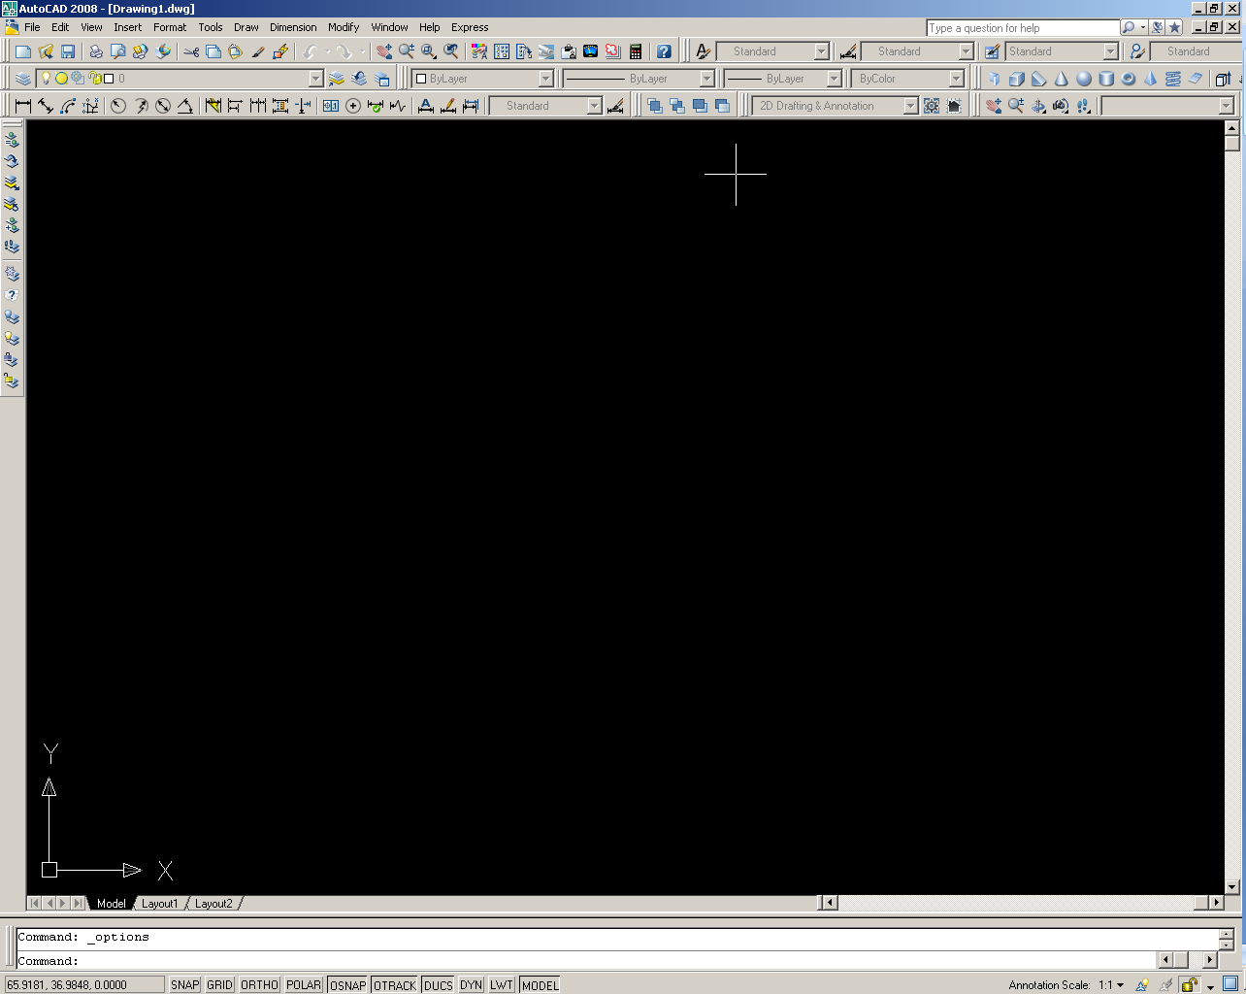

1. From the drop down menu at the top of the Sheet Set Manager, select “New Sheet Set…”.
2. Select “Existing Drawings”, and click next.
3. Type in the name of the sheet set, which should be in the format: project # - keyword (ex. 090674 – LARZ).
4. Store the sheet set data file (.dst) under: …\Drawings\Working_Set\_Support\ and click next.
5. Browse to the folder where the drawings you wish to add are located. Once you have selected the folder, you can deselect any layouts you do not wish to have. Browse to all the folders you wish to add, and then click next.
6. Check which drawings have been added to your sheet set and click finish.
7. To add more layouts after you have created the Sheet Set, right click on the name of the sheet set in the Sheet Set Manager (or on any one of the layouts under that, which will insert the new layouts beneath that point), and select “Import Layout as Sheet…”.

## Create And Edit Blocks

One of the key advantages of creating a block is that you can change the block later and it will update all instances of it within your drawings. Since it is very common to go back and edit minor details in your drawing, instead of having to make the changes multiple times in model space, you can edit it once as a block and all of the copies will be automatically updated.

Steps

1. Type the command ‘be’. The Edit Block Definition window should pop up.
2. To create a new block, simply type a new name of your block into the ‘Block to create or edit’ box and click OK.
3. To edit an existing block, select it from the list or type in the existing name, and click OK.
4. The block editor will now open and you can create the item(s) of your drawing that will be contained within that block.
5. To set the reference point from which your block will be inserted, type ‘bparameter’, then type ‘b’ for base and select the point.
6. When finished, select ‘Close Block Editor’ and select ‘Yes’ to save the changes to block.
7. To insert a block into your drawing type ‘i’ and select the name of the block. Generally, only the check boxes for “Specify On-screen” and “uniform scale” should be checked.
8. You can always go back and edit all of instances of a block in your drawing at the same time by using the block editor (‘be’). If you wish to edit just instance of the block, select that block in your drawing and type ‘explode’. That item in the drawing will no longer be connected the block in any way.

## Calculate Mass & Area Properties

The following outlines steps for determining the mass properties of a shape by cross-section. The massprop command will give you information such as area, perimeter, centroid, moments of inertia, and radii of gyration.

The first step is to draw a section of the shape you need properties for. Here is an example:

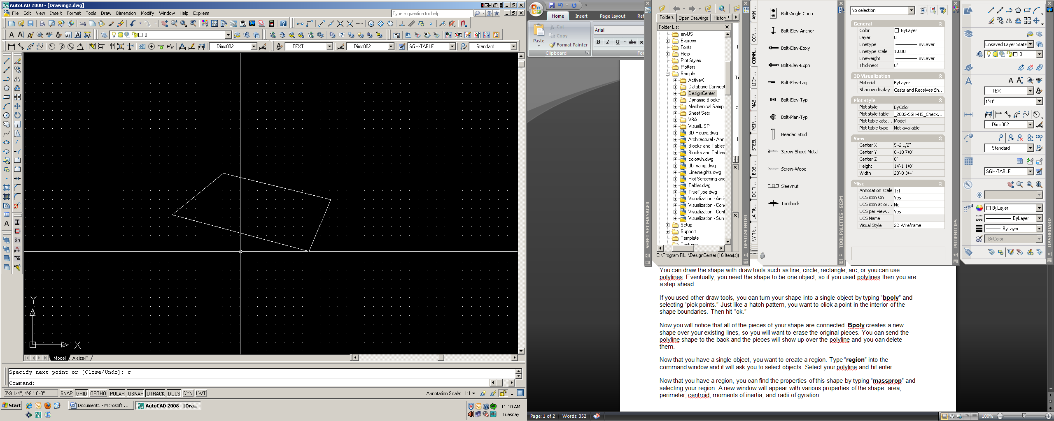

You can draw the shape with draw tools such as line, circle, rectangle, arc, or you can use polylines. Eventually, you need the shape to be one object, so if you used polylines then you are a step ahead.

If you used other draw tools, you can turn your shape into a single object by typing “bpoly” and selecting “pick points.” Just like a hatch pattern, you want to click a point in the interior of the shape boundaries. Then hit “ok.”

Now you will notice that all of the pieces of your shape are connected. Bpoly creates a new shape over your existing lines, so you will want to erase the original pieces. You can send the polyline shape to the back and the pieces will show up over the polyline and you can delete them.

Now that you have a single object, you want to create a region. Type “region” into the command window and it will ask you to select objects. Select your polyline and hit enter.

Now that you have a region, you can find the properties of this shape by typing “massprop” and selecting your region. A new window will appear with various properties of the shape: area, perimeter, etc.:

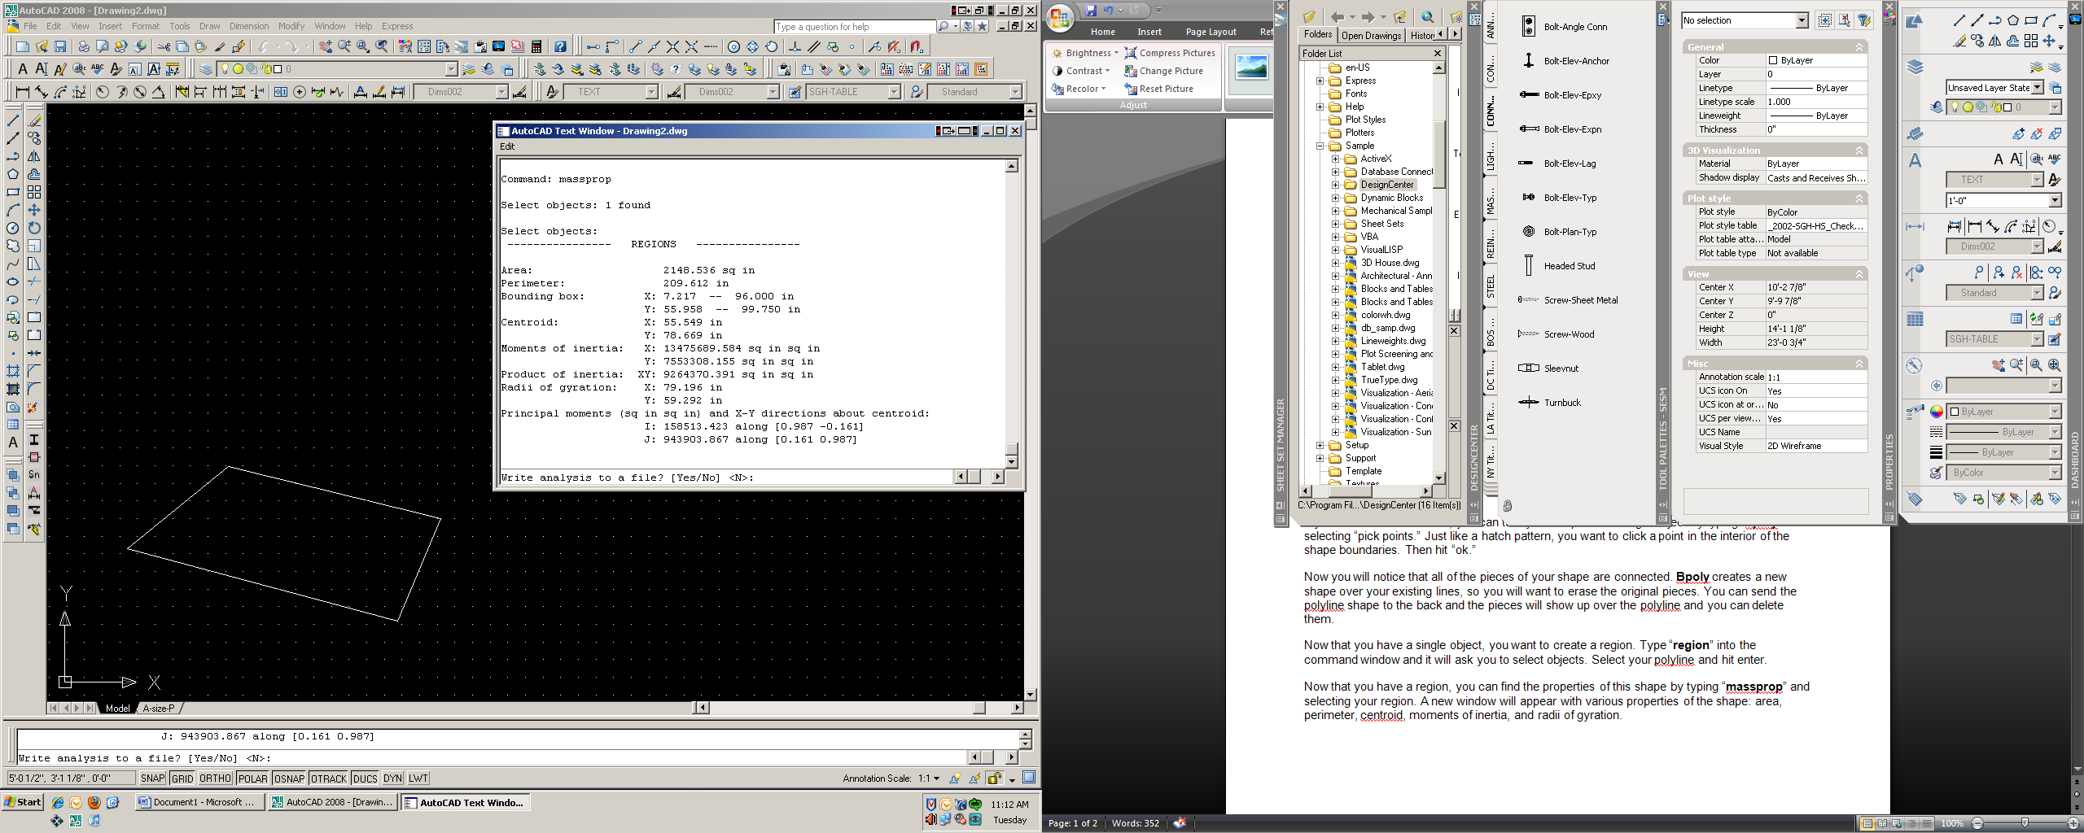

Note that the moments of inertia of this shape are taken from the origin and are not accurate unless the centroid of the shape is located at the origin. To obtain the true moments of inertia, write down the centroid coordinates displayed in the properties menu. Next use the move command and type in the centroid coordinates for the base point. For the second point, enter in (0,0).

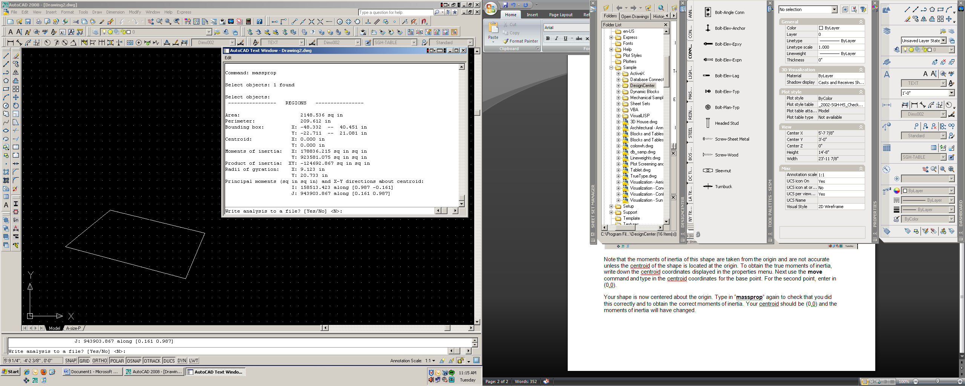

Your shape is now centered about the origin. Type in “massprop” again to check that you did this correctly and to obtain the correct moments of inertia. Your centroid should be (0,0) and the moments of inertia will have changed.

You are done. Read off any values that you need.

## How To Plot Or Print:

While printing out a drawing may seem like a simple task (and often is), it can also end up being one of the most time consuming tasks when it goes wrong. For that reason, it is important to try to follow the standard procedures for printing when at all possible.

### Plotting from Sheet Sets

#### Single Drawing

Steps

1. File > Plot…
2. If your page setup is correct you should be able to press “OK” and plot right away. However, this is more often the exception than the norm.
3. Select your plotter (Bos-Plotter-BW.pc3 or Bos-Plotter-BW2.pc3, unless printing 8.5 x 11 or 17 x 11 in which case choose whichever printer is closest to you, Watertown is closest to the co-op corral in the drafting area).
4. Plot style table should be _2005-STV-FS.ctb for full scale or _2005-STV-HS.ctb for half scale (unless not an STV drawing, in which case you should use the client’s pen style or the line weights may not print correctly. Sometimes the engineer or drafter on the project will need to ask the client for this .ctb file).
5. Select your desired paper size.
6. Under “What to plot:”, ideally you select Window, then click Window< and type 0,0 and the coordinates of the far corner of the page (i.e. 17,11 or 48,36 etc.). However, if you click Preview and the plot does not appear correct, try changing “What to plot:” to Extents.
7. Click OK.

#### Multiple Drawings

The most efficient way to print multiple drawings is by using a sheet set. If the layouts you want to print are not already a part of a sheet set, you can quickly create one (See *How to create a sheet set*).

Steps

1. Make sure all the changes you have made to your drawings are saved and open up the sheet set with the drawings you want to print.
2. If you are printing all of the layouts, right click on the name of the sheet set. If you are only printing some of the drawings use Ctrl + select to choose multiple drawings and then right click on any one of those drawings.
3. Select Publish > Publish Dialogue Box… (See Figure below)

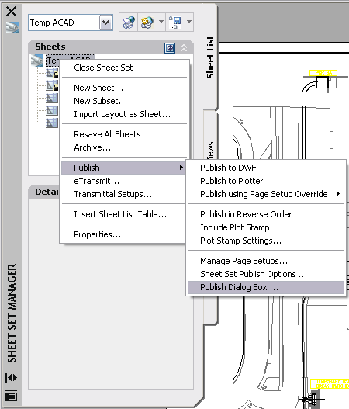

1. Change all of the “Page Setup / 3D DWF” to desired page setup. This is most easily accomplished by highlighting all of the layouts and selecting the page setup from the drop down menu on the top item (See Figure below). You will need to have a page setup already defined with the correct settings because you cannot modify the page setups from this screen.

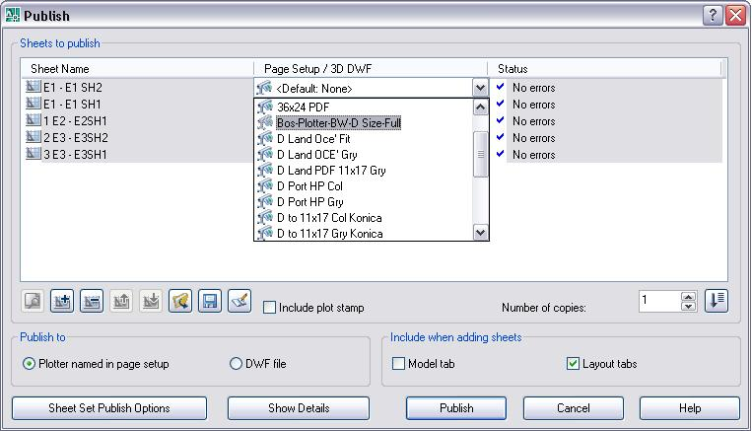

1. If the drawing is for internal use only, it is often helpful to check “Include plot stamp”, which will print the location of that AutoCAD on the side of the drawing.
2. Click Publish to send the drawings to the plotter.

### PDF Plotting

#### Single Drawing

Engineers often need drawings plotted to PDF to send to a client, or for mark up or documentation purposes.

Steps

1. Under Page Setup, make sure the appropriate “PDF-? SIZE” from the STV standard setups is available in the list (you do not need to set as current).
   1. If the appropriate “PDF-? SIZE” is not there, you can either import it by clicking Import > 2006_DESI TEMPLATE - PLANS.dwt > “PDF-? SIZE” > OK, or you can create a new setup on your own.
   2. If you want to create a custom page setup for printing to PDF’s, the plotter must be set to PostScript Level2.pc3.
2. Select File > Publish…
3. Doing this will automatically select all of the drawings in that file. If you wish to only print one, you can simply select and delete the other drawings from the list.
4. Change the “Page Setup / 3D DWF” to desired page setup. You will need to have a page setup already defined with the correct settings because you cannot modify the page setups from this screen.
5. Select Publish Options…
6. Under Location: browse to:

I:\BOS\Drafting Standards\_PDF\#x#\in

Where #x# is replaced by your drawing size.

1. Select OK to return to the Publish screen and click ‘Publish’.
2. After the program runs, your drawing should appear in:

I:\BOS\Drafting Standards\_PDF\#x#\out

If the PDF does not appear right away, check with Kevin Guillotte because the program actually runs remotely on his computer and he must have the software running (normally you do not have to ask).

#### Multiple Drawings

The steps for printing multiple drawings to PDF are basically a combination of plotting multiple drawings and printing a single PDF.

Steps

1. Under Page Setup, make sure the appropriate “PDF-? SIZE” from the STV standard setups is available in the list (you do not need to set as current).
   1. If the appropriate “PDF-? SIZE” is not there, you can either import it by clicking Import > 2006_DESI TEMPLATE - PLANS.dwt > “PDF-? SIZE” > OK, or you can create a new setup on your own.
   2. If you want to create a custom page setup for printing to PDF’s, the plotter must be set to PostScript Level2.pc3.
2. Follow Steps 1 to 4 of “Plotting multiple drawings”.
3. Then follow Steps 5 to 8 of “Printing a single drawing to PDF”.

# EXPORTING AUTOCAD DRAWINGS

# Exporting Into Revit

It’s possible that this should be in the nonexistent Revit section, but I didn’t feel it was worthwhile to make a whole new section for something that kind of fits in the AutoCAD anyway.

So, someone asks you to move some details from AutoCAD to a sheet set in Revit. This is only for printing purposes – once these details are in Revit, you won’t be able to edit them.

1. Make sure you don’t have a title block in AutoCAD. If you do, get rid of it. The title block should be in Revit.
2. Print the drawing to PDF. Make sure it is the size you want the final sheet to be when it is printed, and that it matches the size of the title block in Revit.
3. Open the PDF in our PDF editor. Not Adobe, that Nuance PDF Convertor. Save the PDF as a PNG.
4. Attempt to open Revit.
5. Go get a coffee. When you return, Revit might be open.
6. Go to the sheet you want the drawings to be a part of. Click Insert, the Image. Browse to the PNG you just made. When it inserts, it will be huge. Just drop it in the middle of the title block.
7. Now resize. You can use the little measurement tool in Revit to measure the title block, and then select the inserted image to change its size. You only need to change one dimension; the other will correct itself to match. Then snap one of the corners to the corner of the title block.

Congratulations! You have inserted an AutoCAD drawing into Revit.

# Exporting Into Abaqus

# CAD EXERCISE

# Foundation Exercise

## Objective

Learn to use STV layers, draw to scale text heights, and create block references and viewports.

## Procedure

Open AutoCAD 2013 and create a new drawing template to work from:

* Open a new file (File > New).
* When creating a new drawing you should start with one of the standard STV templates. These can be found under: I:\BOS\Drafting Standards\_AutoCAD Shared\_Templates\STV page setups - bos. You may be required to change the “file type” drop down menu to a drawing template file (.dwt). You should now see a list of templates.
* You will probably want: “STV Template-Imperial”. Open the desired template.
* Note: In most jobs you will work on at STV, you will be editing or adding to existing drawings, in which case you will not have follow these steps to set up a drawing.

## Paper Space Set Up

Change the paper space size of the drawing from 8-1/2 in. x 11 in. to 24 in. x 36 in:

* In the lower left-hand corner of the window, right click on the sheet “Layout 1” tab (It may also just be called Layout 1; this tab can be renamed, just like in Excel).
* Select “Page Setup Manager.”
  + The page setup determines the features of your layout. It sets the default printer (Plotter BW, Plotter-Color, or print to PDF), the size of the drawing (A through F) and whether the drawing will print to the Full size of your layout or Half the size. Selecting Full or Half size will not affect the size of your drawing in AutoCAD, only the size of paper to which it will plot.
* Select “Bos-Plotter BW-D Size Full” in the page setup list. This will set the Boston black and white plotter as the default, the paper size to D size (42 x 36 in.) and the plot setting to Full (will print to 42 x 36 in. as well).
* Click the “Set Current” button to apply your changes to your selected tab.

## Model Space Set Up

1. We would like to end up with three details boxes at different scales: ¾”=1’-0”, 1”=1’-0” and 1-½”=1’-0”. To do so, make sure you have the dim styles for each of these scales. In case you don’t read above how to insert dim styles, and add the appropriate dym styles.

* Go back to the model space by clicking on the “model” tab. Select the dim style you wish to start working and click on the Detail Box on your tool palette, and insert it into you model space. Repeat this procedure, making sure to alter the dim style for each of the scales you are going to be drawing in.

## Drawing

1. Create the drawing shown in Figure 1 without labeling the dimensions. Once you create one of your drawings you should be able to copy it (by selecting all lines) and pasting it.

* Produce the foundation drawing with the dimensions shown in Figure 1. To make this task easier, you should have the STV Tool Palettes installed (See “How to Install Tool Palletes” in the Co-op Student Manual). Using items on the STV Tool Palettes will automatically use the correct layers. Figure 2 shows which items can come from the tool palettes.
  + The wall and footing lines should be drawn on the “DETL-SECT” layer. It is preferable to use polylines rather than normal lines because it will make the shape easier to hatch.
  + The reinforcement bars should be added on the “DETL-REIN” layer. Rebar elevations can be drawn in two ways:
    - Using ½ in. polylines. This is the old way and should be avoided if possible.
    - The preferred method is to pick it from the tool palette and modify it (Open the Tool Palette > click on Properties in the bottom-left corner > SESM > click on the Reinforcement tab > REBAR-ELEV or STD-HOOK-90). After correctly positioning your rebar, select the rebar and click on the downward arrow to select the appropriate bar width (#4 for this drawing).
  + Reinforcement cross-sections should also be added to the “DETL-REIN” layer. Rebar sections can be drawn in two ways:
    - Using 1 in. solid circle with “donut” command. This is the old way and should be avoided if possible.
    - The preferred method is to pick it from the tool palette and modify it (same as above except > REBAR – SECT (EXAGGERATED)). After correctly positioning your rebar section, select the rebar and click on the downward arrow to select the appropriate bar size (#5 for this drawing).
  + The rough connection between the wall and footing should be added using the tool palette (Tool Palette – SESM>Concrete> ROUGH – SURF).
  + The break line on the top of the wall should be added using the tool palette (Tool Palette – SESM > Annotation > BrkLine).
  + The concrete pattern should be added using the “hatch” command to the “PATT-CONC” layer. Use the “AR-CONC” pattern at 0.5 scale (however the scale can be adjusted until it “looks right”).
  + Do not add the leaders and the dimensions to the foundation block. You will add those in the actual model space because there will be different labels required for each drawing.

## Adding Dimensions

* Reproduce the dimensions and text shown in Figures 3, 4 and 5.
* Dimensions should be added on the “ANNO-DIMS” layer and text on the “ANNO-TEXT” layer.
* It is very important to have your dimensions and text set to the correct scale, so that when the drawings are scaled in paper space the text all appears to be the same size.
* Use the standard STV dimension styles, which should already be present on your computer under the Dimension Style Manager
  + Since the ¾”=1’-0” scale has a scale factor of 16, the dimensions for the ¾”=1’-0” drawing should be set to DIMS016. Similarly, DIMS012 should be used for the 1”=1’-0” scale and DIMS008 for the 1-½”=1’-0” scale. The same is also true for leaders with arrows, leaders with dots, leaders with loops and leaders with tildas, which all have their own respective styles under the Dimension Style Manager.
* Edit the “detail titles” as shown in the attached examples, by double-clicking on them.

## Creating Viewports

Setup 3 viewports at the paper space of to each display one of the drawings:

* Switch back to your layout in Paper Space by clicking on the tab labeled Layout 1 (or whatever you renamed it).
* Set the layer command to “Defpoints”.
* Create 3 viewports (View > Viewports > 3 Viewports > Type “v” for vertical > “0,0” for first point > “36,24” for opposite corner). This will create 3 equally sized viewports.
* Double-click on the first viewport to make it active.
* Type “z” (for zoom) and then “1/16xp” to set up the ¾”=1’-0” scale. This scales the drawing to 1/16th of the true size of the page when plotted.
* Pan and center Detail 1 in your in the first viewport.
* Repeat the same scaling process for the other two details using “1/12xp” for the 1”=1’-0” scale detail and “1/8xp” for the 1-½”=1’-0” scale.

## X-Reference Title Block

1. We would also like for our drawing to have a title block. The STV title blocks are located in the STV Tool Palettes. If you didn’t add them earlier, add them now. To install the Tool Palettes, see “How to Install Tool Palettes.”

* Title blocks are not inserted directly into the drawing, but rather xref’d in, so to create a title block for this drawing, we’ll have to create another new drawing entirely. Follow the steps above to create a new drawing, skipping step 3.
* Go to the model space. In the STV Tool Palettes, select the tab BOST STV TitleBlocks. Since this is a 24in x 36in drawing, select the appropriate size for the title block. Insert into model space at 0,0. Although we will xref the title block into paper space of our drawing, the title block in the original file is kept in model space.
* Title block files are saved in the Support directory. Use the file naming convention (found on the drafting cheat sheet) to the save the title block there.
* In the original title block file, you only want to fill in the title block information that is common to the entire project. Fill in the project name, project title, project address, and project number. Add the following information to the title block:
  + Project Title: Co-op AutoCAD Tutorial
  + Project Name: STV Co-op Orientation
  + Project Address: 41 Seyon St., Waltham, MA 02453
  + Project Number: 000180.51
* Attributes that are drawing-specific, like the drawing title, date, drawn by, checked by, approved by, scale, drawing status, drawing number, scale, etc., should be in drawing files itself. Where there are placeholders for this information in the title block, delete. Make sure there is nothing else in the model space of this drawing (because it will show up in the xref as well). Now save the file, and close.
* In your drawing file, go to the paper space. In the external references palette, click Attach Drawing (upper left-hand corner). Navigate to and select your title block file. Leave the reference type as attachment and select Relative Path for the Path Type. Click OK. Insert at 0,0.
* Now we need to add our drawing-specific information to the title block. Go to the BOST STV Title Blocks tab on the Tool Palette again, and select the Drawing Title-Text-D under Drawing Sheet Title Text Blocks. Insert at 0,0.
* Add the following information to the title block:
  + Drawing Number: S1.0
  + Drawing Title: Foundation Sections
  + Date: the date
  + Drawn By: your initials
  + Scale: We used different scales for each detail, so put ‘As Noted’

## Align Details

Align details for proper presentation:

* In paper space, draw a line aligned with the bottom of the first detail box all the way to the third detail.
* Pan in the other two viewports so that the detail boxes are aligned with that line in paper space. Then delete the line in paper space.

## Print Drawing

Print to BOS-Plotter-BW.pc3, 24x36, plot style table 2005STV.cbt (should have these settings by default).

See Scott Webber if this is not working for you. Final output should appear similar to the Foundation Tutorial Final.pdf.

# REFERENCES

This tutorial was done using information from the following documents and Authors.